**Project Design Phase I**

This is a textbox...

**Technology Architecture**

|  |  |
| --- | --- |
| **Date** | 14 October 2022 |
| **Team ID** | PNT2022TMID23120 |
| **Project name** | Early Detection of Chronic Kidney Disease |
| **Maximum marks** | 2 Marks |

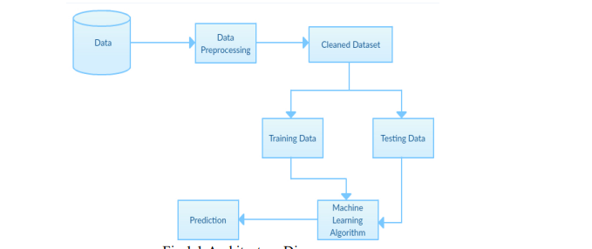Table-1 : Components & Technologies

|  |  |  |  |
| --- | --- | --- | --- |
| **S.N o** | **Component** | **Description** | **Technology** |
| 1 | User Interface | How user interacts with application e.g. Web UI | HTML, CSS, Python Flask |
| 2 | Application Logic-1 | Get input from the user | HTML, CSS, Python Flask |
| 3 | Application Logic-2 | Predicts based on the provided input | Python |
| 4 | Application Logic-3 | Displays the predicted Result | Python, HTML, CSS, Flask |
| 5 | File Storage | File storage requirements | IBM CLOUD |
| 6 | Machine Learning Model | Random Forest, Regression techniques,  Decision tree and SVM | Prediction and Classification |
| 7 | Infrastructure (Server / Cloud) | Cloud Deployment | IBM CLOUD |

:

Table-2: Application Characteristics:

|  |  |  |  |
| --- | --- | --- | --- |
| **S.N**  **o** | **Characteristics** | **Description** | **Technology** |
| 1 | Open-Source Frameworks | Development and Deployment | IBM Cloud, Python |
| 2 | Security Implementations | Security provided by IBM Cloud | Workload Protection, Identity and Access Protection |
| 3 | Scalable Architecture | Model can be scalable | Python |
| 4 | Availability | Available in the cloud | IBM CLOUD |
| 5 | Performance | High accuracy Performance | Machine Learning Prediction and  Classification techniques |